
UNIVERSITY OF ENGINEERING AND TECHNOLOGY, LAHORE

Department of Computer Science

Project Title:
Tech Product Launch: Website Report and Analysis

Submitted By:
Ayesha Fayyaz - Roll No: 2025-GA-21
Qiraat Tahir - Roll No: 2025-GA-50
Meerab Zahid - Roll No: 2025-GA-43
Umair Abu Bakar - Roll No: 2025-GA-04
M.Daud Butt - Roll No: 2025-GA-38

Instructor: Ms. Ramsha Khalid

Course Name: Application of Information and Technology Lab (AICTL)

Section: Gaming and Animation (A)

Contents
- Introduction
- Company overview
- Detailed analysis of products
- Holographic Desk
- Smart Mirror
- Smart AI Robot
- Prices
- Future impact analysis
- Privacy Policy analysis
- Website strengths
- Professional conclusion
- References

- Introduction:
This document provides a detailed report and analysis of the FUTURE TECH website titled Tech Product Launch. The website focuses on launching innovative future technology products designed to enhance productivity, health, and daily life through artificial intelligence, smart systems, and immersive technology experiences.
We all know technology is changing fast. What was science fiction a few years ago is pretty much our everyday reality now. At future tech product, our goal is simple to bring some of that future into your home or office today.
In this document, we are excited to show you a few items we think you’ll really like: our Holographic Desk, the Smart Mirror, and the Smart AI Robot.
They are not just new products, they are our take on what living and working in a connected world should feel like. Let’s see what the future has in store.
- Company Overview:
FUTURE TECH began as a student-led initiative, driven by curiosity and innovation. The company evolved into a technology-focused enterprise developing AI powered products designed for smart living.
FUTURE TECH is a specialized tech venture that focuses on practical automation and interactive hardware. They build physical tools that change how people interact with their surroundings. The company is trying to prove that the future of tech. It’s isn’t just about software, it’s about how that software lives in real world.
FUTURE TECH is not just launching random gadgets, they are targeting specific gaps in the market. For instance, while most companies are focused on making thinner phones. Their approach is focused on “utility over hype”.
By developing the Holographic Desk, the Smart Mirror, and the AI Robot as a connected set, they are creating a set where hardware actually assists. The company emphasizes ethical data use, user privacy, and sustainability as a part of its corporate values. The mission of the company is to empower users through intelligent, human centered technology. Their core mission is to enhance the productivity, health and lifestyle.
- Detailed Analysis of Products:

  - Holographic Desk:

A holographic desk is an interactive display table that uses advanced light-field technology to project and display three-dimensional (3D) images that appear to float in the air, allowing multiple users to view and interact with the content from different angles without the need for special VR headsets or glasses.
Key Features:
- Interactive 3D holographic display
- Gesture-based controls for hands-free operations
- Multi-tasking support for multiple applications simultaneously
- Clutter-free workspace enhancing productivity
Target Users:
- Designers
- Engineers
- Students
- Researchers
  - Smart Mirror:

A smart mirror is an interactive, two-way mirror equipped with an integrated digital display and computing system that provides information, entertainment, and enhanced functionality beyond a standard reflection. When the display is off, it functions as a normal mirror. When activated, digital content appears as an overlay on the reflective surface.
Key Features:
- Real-time health monitoring
- Posture and skin analysis
- Contactless tracking
- Personalized daily health summaries
Target Users:
- Fitness enthusiasts
- Health-conscious individuals
- Busy professionals
- Families
  - Smart AI Robot:

A smart AI robot is an advanced, physical machine that uses artificial intelligence (AI) to perceive its environment, learn from experience, make autonomous decisions, and perform tasks with minimal human intervention. Unlike traditional robots which follow rigid, pre-programmed instructions, smart robots can adapt to changing and unpredictable situations.
Key Features:
- voice-controlled assistance
- Smart scheduling and reminders
- Personalized responses based on habits
- Adaptive learning and continuous improvement.
Target User:
- Professionals
- Students
- Smart home users

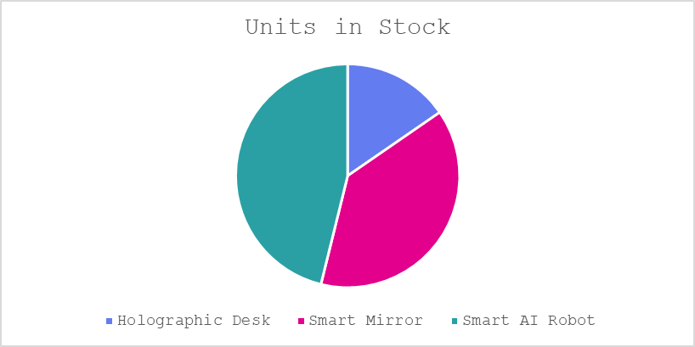
Figure 1: Units in stock
- Prices:
Product name | Price | Description
Holographic Desk | $14,499 | Futuristic workstation projecting interactive holograms
Smart Mirror | $5,499 | Real-time wellness insights and health tracking
Smart AI Robot | $40,099 | Personal AI assistant managing tasks intelligently

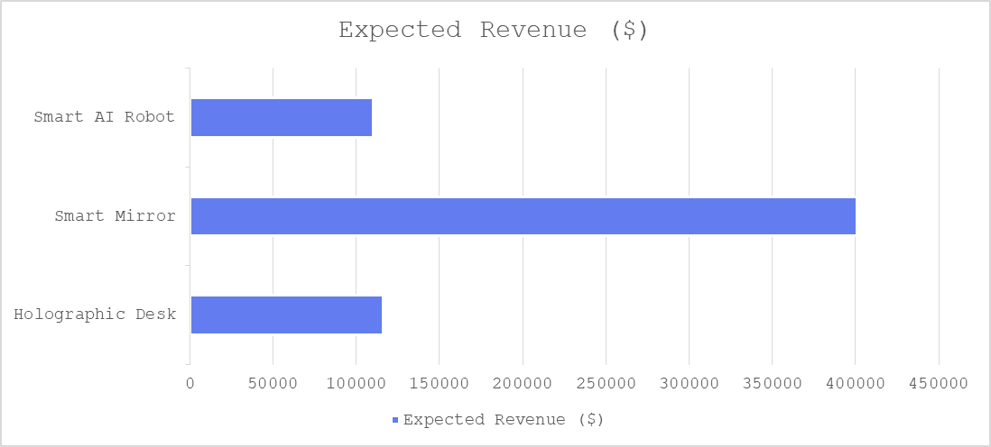
Figure 2: Expected Revenue
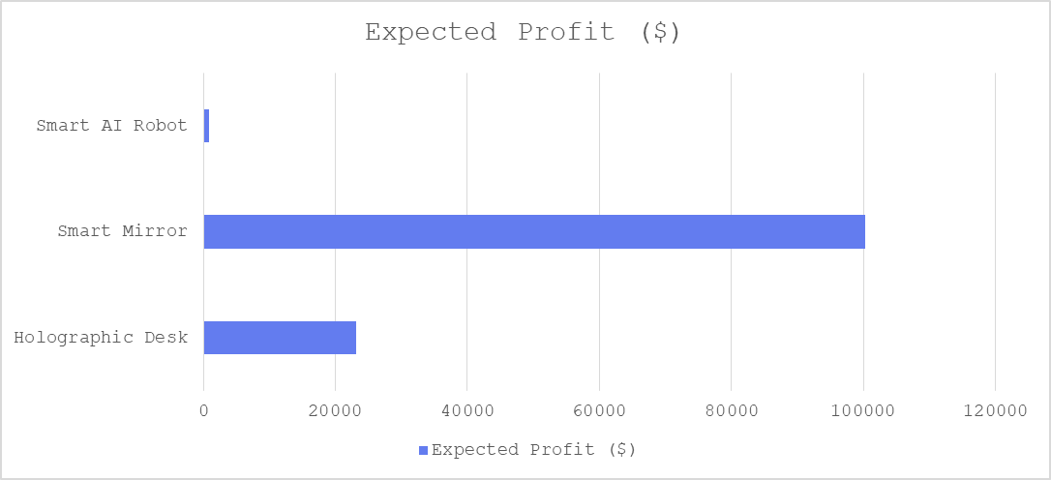
Figure 3: Expected Profit
- Future Impact Analysis:
The integration of the Holographic Desk, Smart Mirror, and AI Robot into daily life represents a fundamental shift in how people interact with their surroundings. Instead of relying on traditional screens, the future points toward a 3D workspace where digital data and physical reality blend seamlessly.
This transition will likely reduce the need for bulky hardware, leading to more sustainable and minimal living environments. By the year 2026 and beyond, the biggest impact will be seen in personal productivity and wellness; as the Smart Mirror tracks health metrics effortlessly and the AI Robot handles routine chores, individuals will gain more time to focus on creative and meaningful work.
There is a huge amount of public interest in these technologies because people are looking for ways to simplify their busy lives. The future impact of the Holographic Desk, Smart Mirror, and AI Robot will be seen in how we move away from traditional screens and bulky devices.
By 2026, as these products become more common, they will change the way we manage our health and work from home. Since people are already very curious about these inventions, their adoption will likely be fast. This shift will allow individuals to spend less time on repetitive chores and more time on things that actually matter. Eventually, these products will turn a regular house into a smart living space that supports its users in every small way.
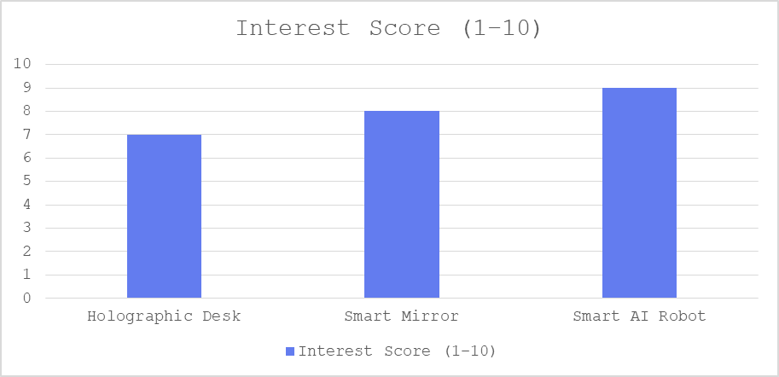
Figure 4: Interest Score
6. Privacy Policy Analysis:
The privacy policy of FUTURE TECH shows that the company takes user privacy seriously. Since FUTURE TECH deals with advanced AI-based products like the Holographic Desk, Smart Mirror, and Smart AI Robot, handling user data responsibly is very important.
First, the policy clearly explains what type of information is collected. This includes personal details, device usage data, and health-related data
Secondly, the policy explains how the collected information is used. The data is mainly used to improve product performance, personalize user experience, and provide better services.
Another strong point of the privacy policy is data security. The company clearly mentions that it does not sell personal data. Information is only shared with trusted third parties such as payment processors and customer support services
The privacy policy also gives users full control over their data. Users can manage permissions and request deletion or correction of their personal information. This makes the policy user-friendly and transparent.
In addition, FUTURE TECH clearly states that its products are not designed for children under 13 years of age. This shows responsibility and compliance with privacy laws related to children’s data.
Overall, the privacy policy of FUTURE TECH is well-structured, easy to understand, and user-focused. It balances innovation with privacy protection, making users feel safe while using advanced AI products. This policy helps build trust and supports the company’s image as a responsible future-tech brand.
7. Website Strengths:
- Clear product descriptions
- Strong branding
- Trust building reviews
- Transparent privacy policy
- Well-defined target audience
8. Professional Conclusion:
The FUTURE TECH website successfully presents innovative technology products with clear value propositions. Its strong narrative, detailed product explanations, and positive user feedback position it as a credible future-tech brand. With minor improvements, the website can further enhance user trust and engagement.
9. References:
- Russell, S. J., & Norvig, P. (2021). Artificial Intelligence: A Modern Approach (4th ed.). Pearson.
- World Economic Forum. (2023). Global Technology Governance and the Future of AI. World Economic Forum Reports.
- McKinsey & Company. (2023). Artificial Intelligence and the Future of Work. McKinsey Global Institute.
- IBM Corporation. (2022). Artificial Intelligence Overview and Applications. IBM Documentation.
- Statista. (2023). Smart Devices and Smart Home Market Statistics. Statista Research.
______________________________________________

